YouTube Chatbot using LangChain | Building a RAG system in LangChain
https://www.youtube.com/watch?v=J5_-l7WIO_w&list=PLKnIA16_RmvaTbihpo4MtzVm4XOQa0ER0&index=17
https://colab.research.google.com/drive/1pat55z_iiLqzInsLi3sWS2wekFCXprQW?usp=sharing
00:00 - Intro
00:57 - Problem Statement
04:46 - Plan of Action
08:55 - Code Demo
32:26 - Improvements
45:48 – Outro
Overview
This project demonstrates how to build a Retrieval-Augmented Generation (RAG) system using LangChain that allows users to chat with the content of any YouTube video. Instead of watching long videos end to end, users can ask questions, request summaries, or clarify specific parts of a video and receive accurate, context-aware responses.
The project focuses on the core RAG functionality, not on UI development. All implementation is done inside a Google Colab notebook, making it easy to understand, test, and extend later with a proper user interface.

Background
In previous videos of the LangChain playlist, the theoretical foundation of RAG was covered, including:
- What RAG is
- Why RAG is needed
- How RAG differs from fine-tuning
- Key components such as document loaders, text splitters, vector stores, and retrievers
This project builds on that knowledge and shows how all these components work together in a real-world application.

Problem Statement
YouTube videos such as podcasts, lectures, and interviews can be several hours long. Extracting specific information from these videos requires watching the entire content, which is inefficient and time-consuming.
The goal of this project is to build a system that allows users to interact with a YouTube video through a chat interface. Users should be able to:
- Ask whether a specific topic is discussed in the video
- Get concise summaries of the entire video
- Ask questions about particular concepts or segments
- Clarify doubts while watching long lectures
This system effectively transforms a static video into an interactive knowledge source.

Solution Approach
The solution uses a Retrieval-Augmented Generation architecture, where external knowledge (YouTube video transcripts) is retrieved and supplied to a language model at query time.
Instead of relying solely on the model’s pre-trained knowledge, the system grounds its answers in the actual content of the video, improving accuracy and relevance.

System Architecture
The project follows the standard RAG pipeline used in LangChain-based applications.
First, the transcript of a YouTube video is fetched. A transcript is a text representation of everything spoken in the video. While LangChain provides a YouTube document loader, it can be unreliable for some videos. To ensure stability, this project uses YouTube’s official transcript APIs.
Once the transcript is loaded, it is usually very large. To handle this efficiently, the text is split into smaller, manageable chunks using a text splitter.
Each chunk is then converted into an embedding and stored in a vector database. This completes the indexing phase of the RAG system.
When a user submits a query, the query is embedded and passed to a retriever. The retriever performs a semantic similarity search on the vector store and fetches the most relevant transcript chunks.
These retrieved chunks are combined with the user’s query to form an augmented prompt. This prompt is then sent to a large language model, which generates a response based on both the question and the retrieved context.

Key Components Used
The project makes use of the following LangChain concepts:
- YouTube transcript loading via API
- Text splitting for large documents
- Embedding generation
- Vector storage for efficient similarity search
- Retriever for fetching relevant content
- Prompt augmentation
- Large Language Model for response generation
Each component is first implemented and tested independently to ensure clarity and correctness.

Execution Flow
The system is initially built step by step so that each stage of the RAG pipeline is easy to understand. After verifying that all components work correctly, they are combined into a single LangChain chain.
In this chained architecture, the output of one component automatically becomes the input of the next. This allows the entire RAG workflow to be executed with a single function call, making the system modular and production-ready.

Implementation Scope
This project intentionally avoids UI development and focuses entirely on backend functionality. The complete system is implemented inside a Google Colab notebook.
Once the core logic is understood and tested, the system can easily be extended by adding:
- A Streamlit web application
- A Chrome extension
- A custom frontend using HTML, CSS, and JavaScript

Final Outcome
By the end of this project, a fully functional RAG-based YouTube chat system is created. The system allows users to query video content intelligently, retrieve accurate information, and generate meaningful responses grounded in the actual transcript.
This project serves as a strong practical example of how RAG can be applied to real-world problems using LangChain.

Code Demonstration: Building the RAG Pipeline
Environment Setup
To build this project, an OpenAI API key is required because OpenAI models are used for embeddings and response generation. Each user must provide their own API key; trimmed or example keys will not work.
After setting the API key, all required libraries are installed. The installation code can be run as-is. Necessary imports are then added to prepare the environment for building the RAG pipeline.
The implementation strictly follows the same RAG architecture discussed earlier, beginning with indexing and moving step by step toward retrieval and generation.
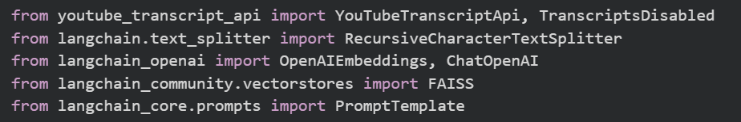

Step 1: Loading the YouTube Transcript
The first task in the indexing phase is to load the transcript of a YouTube video.
This project uses the YouTube Transcript API instead of LangChain’s built-in YouTube loader because it is more reliable across different videos.
Only the video ID is required, not the full YouTube URL. Once the video ID and the desired language are provided, the transcript is fetched directly from YouTube.
The transcript returned by the API is a list of dictionaries, where each entry contains:
- The spoken text
- The timestamp when the text appears
- The duration for which it stays on screen
This format represents subtitles rather than a continuous document. Since a RAG system requires a clean text corpus, all transcript sentences are concatenated into a single large string representing the full video transcript.
If a transcript is not available in English, the language parameter can be changed (for example, to Hindi), allowing transcripts to be loaded correctly for non-English videos.
At this point, the complete transcript of the selected video is successfully loaded into the system.
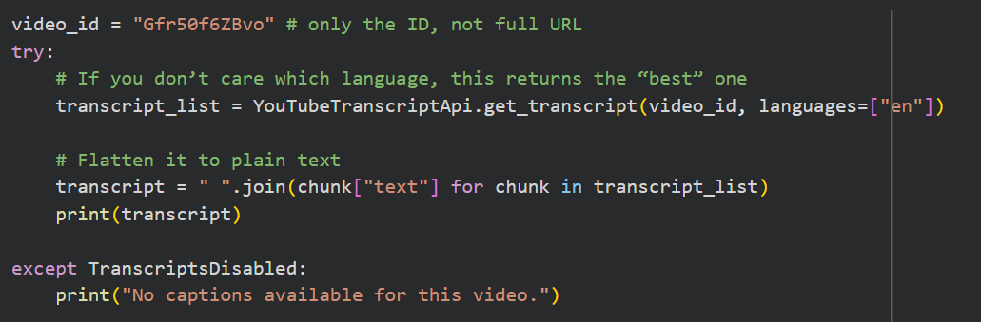
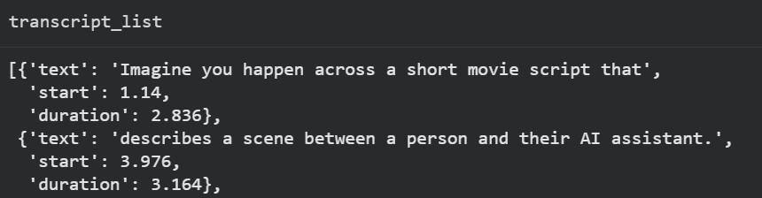

Step 2: Splitting the Transcript into Chunks
Long transcripts cannot be processed effectively as a single block of text. Therefore, the transcript is split into smaller chunks using a Recursive Character Text Splitter.
A chunk size of approximately 1000 characters and an overlap of around 200 characters is used. This overlap helps preserve context between adjacent chunks.
After splitting, the transcript is divided into multiple chunks (for example, around 160–170 chunks for a two-hour video). Each chunk represents a manageable unit of information that can later be embedded and searched efficiently.
This completes the document-splitting stage of indexing.
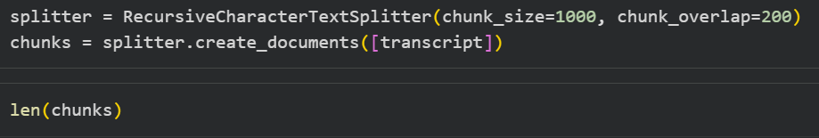
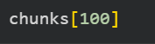

Step 3: Creating Embeddings and Storing in a Vector Store
Each text chunk is converted into a vector representation using an OpenAI embedding model. These vectors capture the semantic meaning of the text.
All embeddings are stored in a FAISS vector store, which allows fast and efficient similarity search. Each chunk is automatically assigned an internal ID and stored along with its vector embedding.
At this stage, the full indexing pipeline is complete:
- Transcript loaded
- Text split into chunks
- Chunks embedded
- Embeddings stored in the vector database
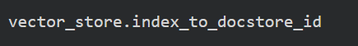
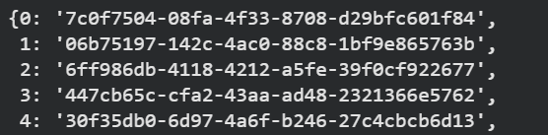
Get the document by id

Step 4: Creating and Testing the Retriever
To retrieve relevant information, a retriever is created from the vector store.
The retriever uses similarity search, meaning it finds chunks whose embeddings are closest to the embedding of the user’s query.
The retriever is configured to return a fixed number of relevant documents (for example, the top 4 most similar chunks).
When a query such as “What is DeepMind?” is passed to the retriever:
- The query is embedded
- The vector store is searched
- The most relevant transcript chunks are returned
The retriever always takes a query as input and returns a list of documents as output.
This confirms that the retrieval stage is working correctly.
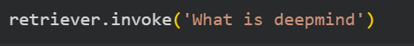
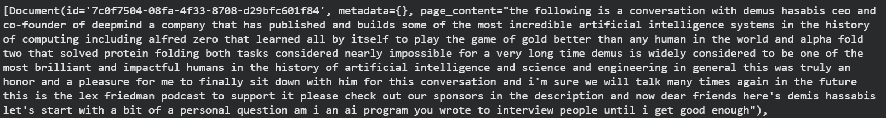

Step 5: Prompt Augmentation
To generate accurate answers, the retrieved documents must be combined with the user’s question into a single prompt.
A prompt template is created with clear instructions:
- The model must answer only using the provided transcript context
- If the context is insufficient, the model should respond that it does not know
The retrieved documents cannot be passed directly to the prompt. Their text content is first extracted and concatenated into a single context string.
At this stage, two inputs are ready:
- The user’s question
- The merged transcript context
These are injected into the prompt template to produce the final prompt that will be sent to the language model.
Create the prompt
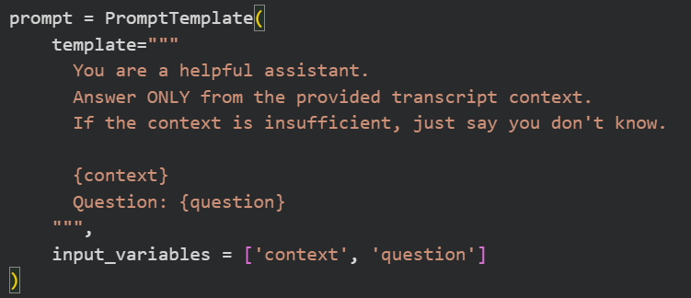
Retrieve the relevant documents from the vector database base on the user query
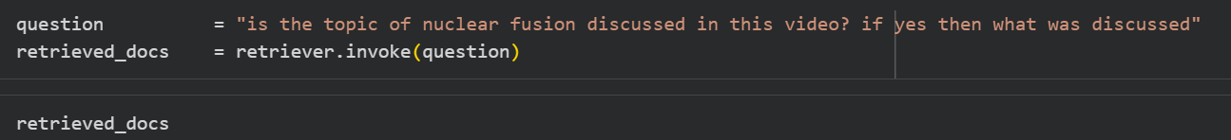
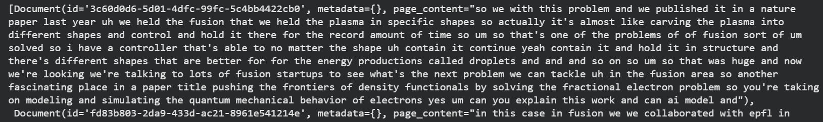
Retrieve only the page content from the above retrieved information
Create the final prompt by combining the context_text retrieved and with the prompt
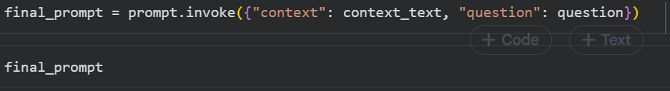

Step 6: Response Generation
The final prompt is passed to the language model, which processes both the question and the transcript context.
The model generates a response grounded entirely in the retrieved transcript chunks. The output may include metadata, but the final user-facing response is extracted as a clean text string.
This confirms that the generation step of the RAG pipeline is working as expected.
At this point, the full RAG pipeline works correctly, but each step still needs to be manually invoked.
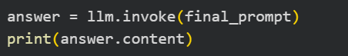

Step 7: Motivation for Using Chains
Manually calling retrieval, prompt creation, and generation is inefficient and error-prone.
To improve code quality and usability, the entire workflow is converted into a LangChain chain, where:
- Each component’s output automatically becomes the next component’s input
- The entire pipeline can be executed with a single function call

Step 8: Building the Parallel Chain
A parallel chain is created to handle two operations simultaneously:
- Generating the context from the retriever
- Passing the user’s question unchanged
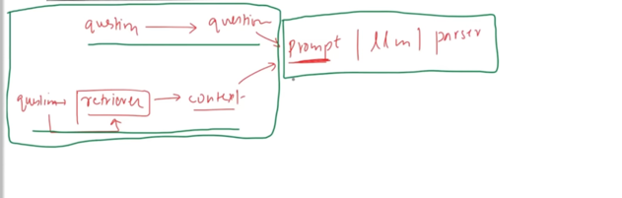
The context pipeline includes:
- The retriever
- A formatting function that merges retrieved documents into a single string
The question pipeline simply forwards the user’s input.
Both pipelines run in parallel and produce a dictionary with:
- A context field
- A question field
This output perfectly matches the input requirements of the prompt template.
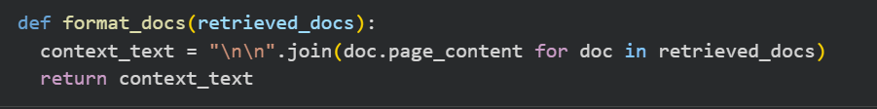
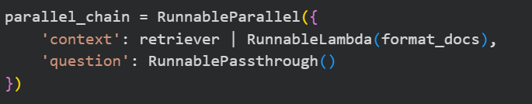

Step 9: Building the Main Chain
A main chain is created by combining:
- The prompt template
- The language model
- A string output parser
This main chain is connected to the parallel chain, forming a complete RAG workflow.
Now, when the chain is invoked:
- The query is retrieved
- Context is fetched and formatted
- The prompt is generated
- The model produces the final response
- The output is parsed and returned
All steps execute automatically.
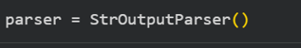
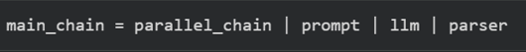
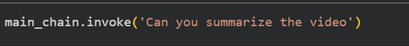

Final Result
The complete RAG pipeline is now clean, modular, and production-ready.
With a single invocation, users can:
- Ask questions about a YouTube video
- Request summaries
- Clarify specific topics discussed in long videos
Indexing is performed once, and retrieval plus generation can be repeated efficiently for multiple queries.
This architecture is scalable, maintainable, and easy to extend with a user interface such as Streamlit or a browser extension.

Improvements: Making the RAG System Industry-Grade
The RAG system built so far successfully solves the core problem statement. However, it represents only a basic, functional implementation. In real-world industry applications, RAG systems are far more complex and robust.
This section provides an overview of how a simple RAG system can be gradually improved and evolved into an industry-grade RAG system. These improvements are optional but highly recommended for production use.

UI and User Experience Enhancements
Currently, the RAG system runs inside a Google Colab notebook. The user must manually:
- Provide the YouTube video ID
- Run notebook cells
- Enter questions programmatically
This workflow is suitable for learning but not for a finished product.
A production-ready system should provide a proper user interface. Possible improvements include:
- Building a web application using Streamlit, where users can paste a YouTube URL and chat with the video.
- Creating a Chrome extension that automatically activates on YouTube pages, allowing users to chat while watching the video.
These UI-based enhancements significantly improve usability and user adoption.

Evaluation of the RAG System
So far, the focus has been on building the RAG system, not evaluating it. However, without evaluation, it is impossible to determine whether the system is performing well or how it can be improved.
Industry-grade RAG systems are rigorously evaluated using dedicated metrics and tools.
One popular library for this purpose is RAGAS, which evaluates RAG systems on multiple dimensions, such as:
- Faithfulness: Whether the generated answer is grounded in the retrieved context.
- Answer Relevance: Whether the answer actually addresses the user’s question.
- Context Precision: How useful the retrieved documents were for answering the question.
- Context Recall: Whether all relevant information available in the vector store was successfully retrieved.
Another important tool is LangSmith, which allows tracing and monitoring each step of the RAG pipeline. This helps identify failures or inefficiencies in retrieval, prompt construction, or generation.
Evaluation is a critical requirement for any production-ready RAG system.

Indexing and Document Ingestion Improvements
The indexing stage offers significant opportunities for improvement.
Currently, transcripts are fetched directly from YouTube, which are often auto-generated and may contain errors. Cleaning and correcting transcription errors can significantly improve answer quality.
If transcripts are in languages other than English (for example, Hindi), they can be translated into English during ingestion to maintain consistency across the system.
Text splitting can also be improved. Recursive character-based splitting may split text in the middle of meaningful paragraphs. A better approach is to use semantic chunking, which preserves logical boundaries and improves retrieval quality.
The current implementation uses FAISS, which is suitable for learning and small-scale projects. For enterprise applications, cloud-based vector databases such as Pinecone or similar managed solutions are preferred for scalability and reliability.

Retrieval Optimizations
Retrieval is one of the most critical stages in a RAG system, and many optimizations are possible.
Pre-Retrieval Enhancements
Before performing retrieval, the user’s query can be improved:
- Query rewriting using an LLM to clarify vague or incomplete questions
- Multi-query generation, where multiple variations of a query are created to capture different perspectives
- Domain-aware routing, where different retrievers are triggered based on the query type
During Retrieval Enhancements
During retrieval, advanced strategies can be applied:
- MMR (Maximal Marginal Relevance) to balance relevance and diversity
- Hybrid retrieval, combining semantic search with keyword-based search
- Re-ranking, where retrieved documents are reordered using an LLM instead of raw similarity scores
Post-Retrieval Enhancements
After retrieval, contextual compression can be applied. This removes irrelevant or low-value text from retrieved documents, ensuring that only meaningful content is passed to the language model. This improves both efficiency and answer quality.

Prompt Augmentation Improvements
The augmentation stage combines the retrieved context with the user’s question.
Prompt templates can be carefully designed to:
- Clearly explain the task to the model
- Include examples
- Explicitly instruct the model to answer only using the provided context
A key technique here is answer grounding, where the model is strictly instructed not to hallucinate or invent facts outside the retrieved content.
Another important concept is context window optimization. Since language models can process only a limited number of tokens, the retrieved context must be trimmed to include only the most relevant information, preventing token overflow.

Generation-Level Improvements
The generation stage can also be enhanced in multiple ways.
One common technique is answer with citations, where the model indicates which part of the context was used to generate each answer.
Another critical improvement is guardrails. Guardrails prevent the model from producing unsafe, incorrect, or inappropriate responses. This is essential for user-facing applications.

Advanced RAG Architectures
Beyond basic text-based RAG systems, several advanced architectures exist.
Multimodal RAG systems can process and retrieve information from text, images, videos, and audio.
Agentic RAG systems allow the model to act as an AI agent. Instead of only answering questions, the system can perform actions such as web browsing or tool usage to gather additional information before responding.
Memory-based RAG systems store past interactions, enabling personalized and context-aware responses across multiple user sessions.

Conclusion
The RAG system built in this project represents only the surface level of what is possible. In real-world applications, RAG systems involve complex pipelines, extensive evaluation, and multiple optimization strategies.
This growing area is commonly referred to as Advanced RAG, which focuses on scalability, reliability, and performance in production environments.
A dedicated Advanced RAG playlist or module is the natural next step after mastering the fundamentals.
